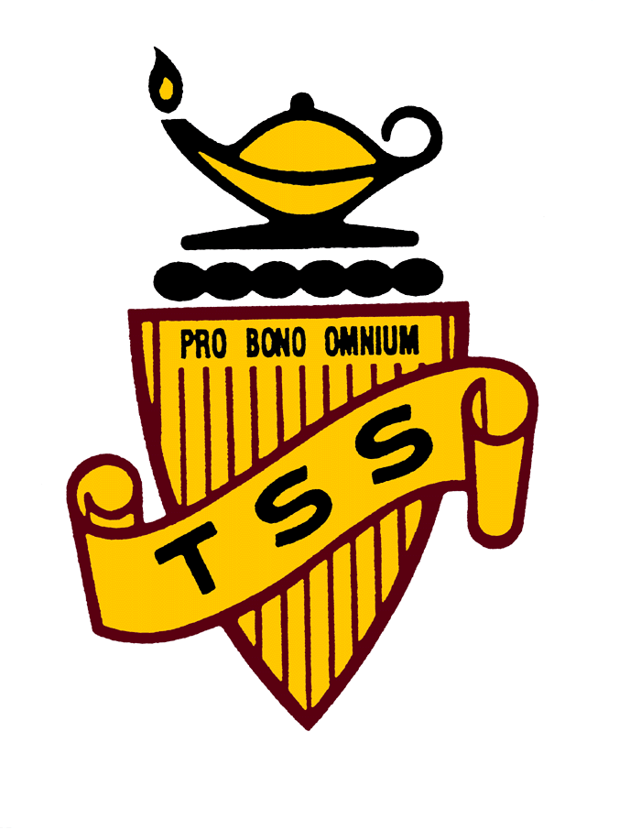

**March 2017**

Principal’s Message 1-3

Titan Athletics 4

Titan Girls Basketball 5

Cypress Mountain Ski &

Snowboard Trip 6

YOE Tackles Warming

Winter Adventures  7-8

First Nations Family Night 9

Grade 7 Conference 10

**Templeton Secondary School Newsletter**

Principal’s Message

Inside this issue:

# March 2017

Principal: Aaron Davis

Vice Principal: Rupi Samra-Gynane

Best regards,

Aaron Davis

Principal

**TITAN AHTLETICS:**

As the Winter Season draws to a close let us take this opportunity to recognize some of the memorable and noteworthy achievements of our Basketball teams. We showcased 6 basketball teams [senior boys 10/11/12, juvenile boys 9, bantam boys 8, senior girls 11/12, junior girls 9/10, and bantam girls 8] all of whom competed diligently and laid the foundation for promising years ahead. Honourable mention goes out to our junior girls who placed 2nd in the Vancouver City Championships earning a silver medal and representing our school admirably. Kudos! The season was capped off in an exciting afternoon of basketball with a staff/student game followed by an alumni/senior boys game. In closing let us take the opportunity to recognize all of our volunteer coaches and team sponsors, scorekeepers, officials, team managers, and community leaders whose selfless contributions make athletics sustainable and enriching at Templeton. GO TEMP!



**We’re on the Web!**

**www.vsb.bc.ca/schools/templeton**

Phone 604-713-8984

Fax 604-713-8983

Templeton Secondary

727 Templeton Dr

Vancouver, BC

V5L 4N8

***Titans Girls Basketball teams finish strong*** – It was an exciting wrap-up to the basketball season this past February, as our girls team battled hard through City play-offs.  The Bantam Girls (Gr.8) finished off their season with an exciting, yet nail-biting loss against Lord Byng.  The Sr. Girls (Gr.11/12) made a strong comeback during play-offs beating Van Tech to secure a 5th spot place in the City finals.  Our Jr Girls (Gr.9/10) won their way to the City Championship, facing a strong Britannia team and taking home 2nd.  It was a fantastic year of basketball from all of our Titan teams!  Players - congratulations on your seasons, your teamwork and on representing Templeton with pride! Go TITANS!

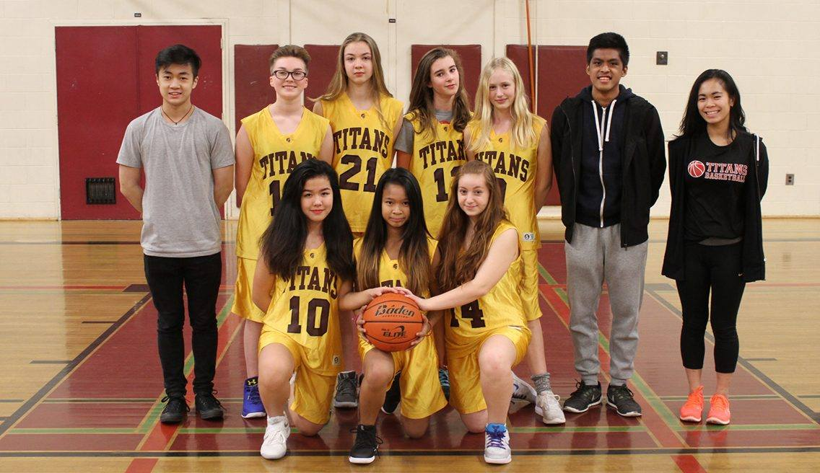

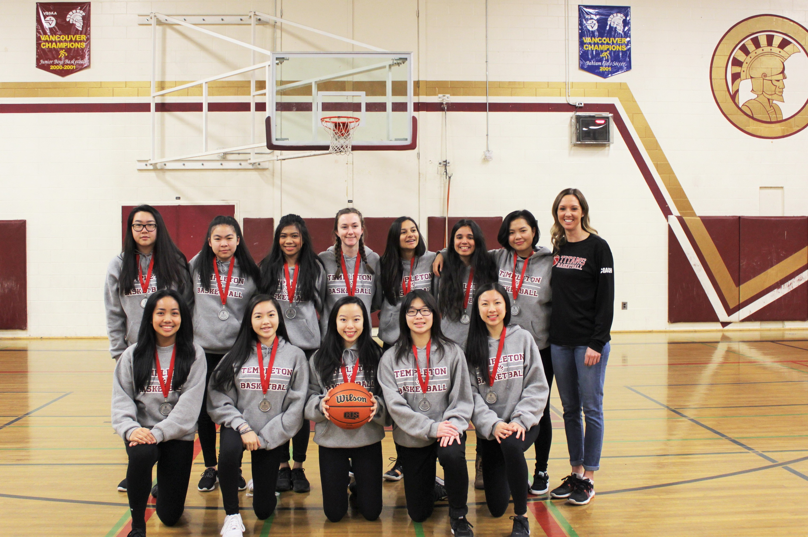

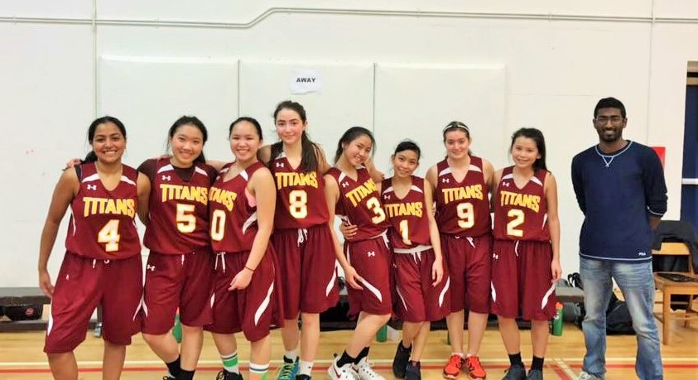

***Cypress Mountain Ski & Snowboard Trip*** – Templeton took to the slopes for their second day of program-based riding this season at Cypress Mountain.  It was a snowy winter wonderland, and although visibility was lost in the clouds, the stashes of powder were easy to find!  Well done skiers & riders on getting out to enjoy an active day in the mountains!

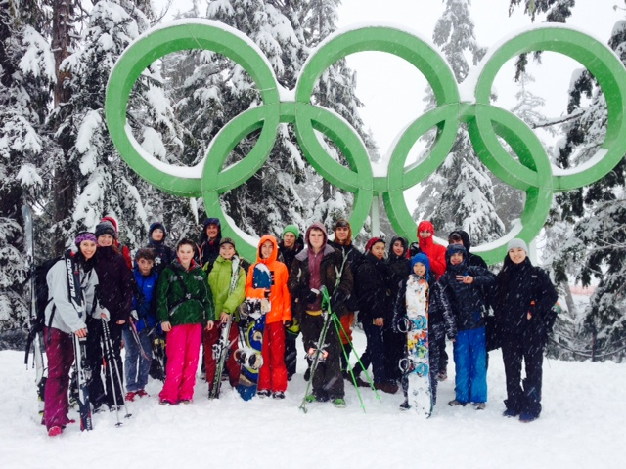

***YOE Tackles Warming Winter Adventures*** - Meters of snow and sub-zero temperatures didn’t stop YOE from enjoying some snowy winter camping and mountain adventures in Manning Park early February.  Snowshoe walks, cross country skiing, downhill riding, snow sculpture competitions and fighting for fire-side warmth made for some great memories at Lone Duck campground and Manning Provincial Park.  Weeks later with a new vigor for winter travel, YOE headed back to Garibaldi, but this time to take on Elfin Lakes in the snow.  Staying in the shelter and sleeping in bunks was comparative luxury and made the 7-hour journey uphill more than worth it!  Never stop exploring.

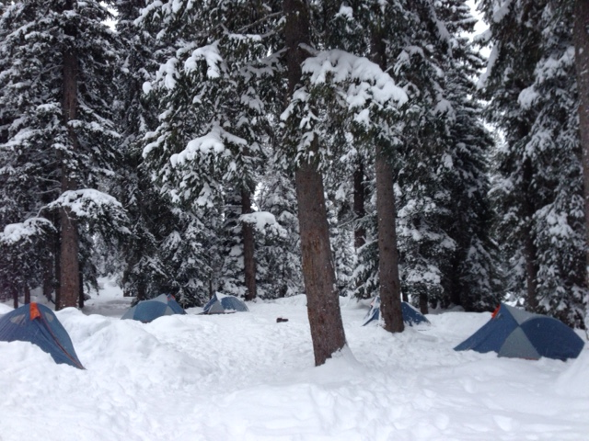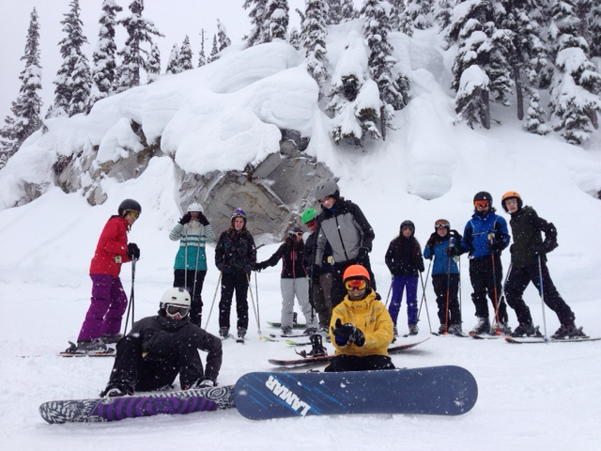

***YOE Tackles Warming Winter Adventures continued…***

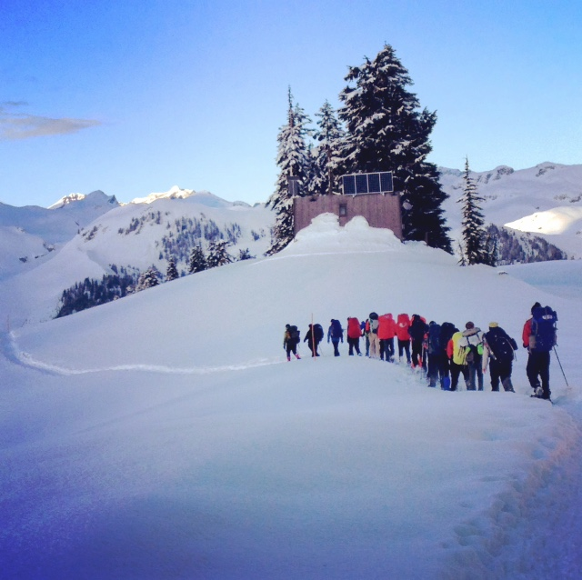

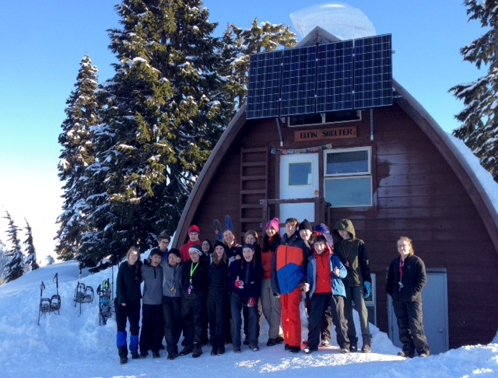

***Templetons' First Nations Family*** night is an annual event that is hosted by the school and it takes place in the large gym. The Family Night connects the families of our students and the recognition of our students for their successes. The family night is open to anyone and the guests are served dinners, followed by First Nations dancers and the recognition of the students.

In the spring of 2008, The Honourable Steven Point, (Retired) Lieutenant Governor of B.C. granted permission for Templeton Secondary School to create these awards to acknowledge our FIRST NATION STUDENTS.

There are door prizes. There is no cost or entry fee. The event is free.  This year Family night is happening on Thursday, April 6th and begins at 5:30 pm.

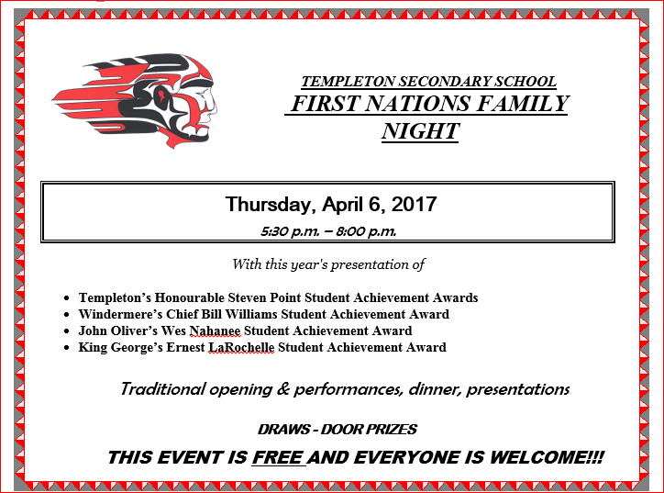

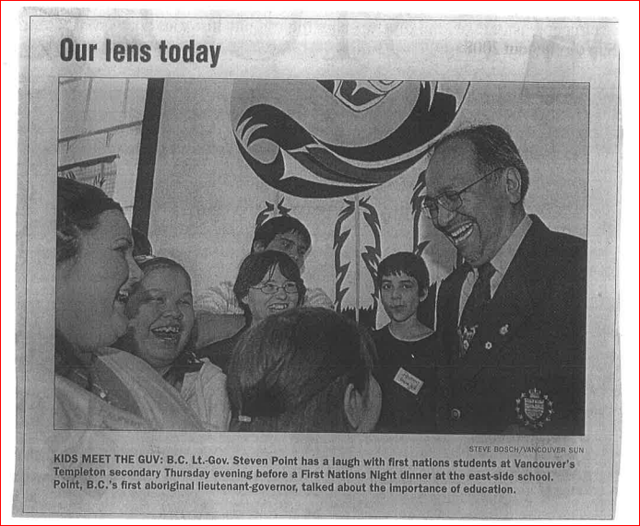

**Grade 7 Conference**

On Thurs, Apr 27th, 160 grade 7’s from our neighbouring elementary schools will take part in our annual Grade 7 Conference hosted at the PNE and Hastings Community Centre. This event aims to help with the transition from grade seven to high school, with our Templeton Titans delivering presentations on the topics of: High School Experience, Health and Nutrition, and Safe Schools and Bullying Prevention. It is a jam-packed day filled with awesome performances and great discussions led by some of our very own Titans. The Templeton CST would like to thank our amazing Titan volunteers, Templeton cafeteria staff and students, Templeton Secondary School admin and staff, Hastings Community Centre, the PNE, SACY, and Vancouver Coastal Health for their support for this very important event.

Paula Parman, Community Schools Team Programmer